Ameliorations? Motor slippage

2.3 Recognition system characteristics

With the system described before, the photodiode gives a current for each motor step, which is converted to a digital number proportional to the magnitude of this current. For each scan of a skin sample (back of hand for each subject), a dataset entry is created, performing the scan and stored, in order to feed a k-NN based recognition system. Those data are associated with spectrums acquired with an GretagMacbeth Eye-One spectrophotometer (previously calibrated with a white object) as described in Figure ?.

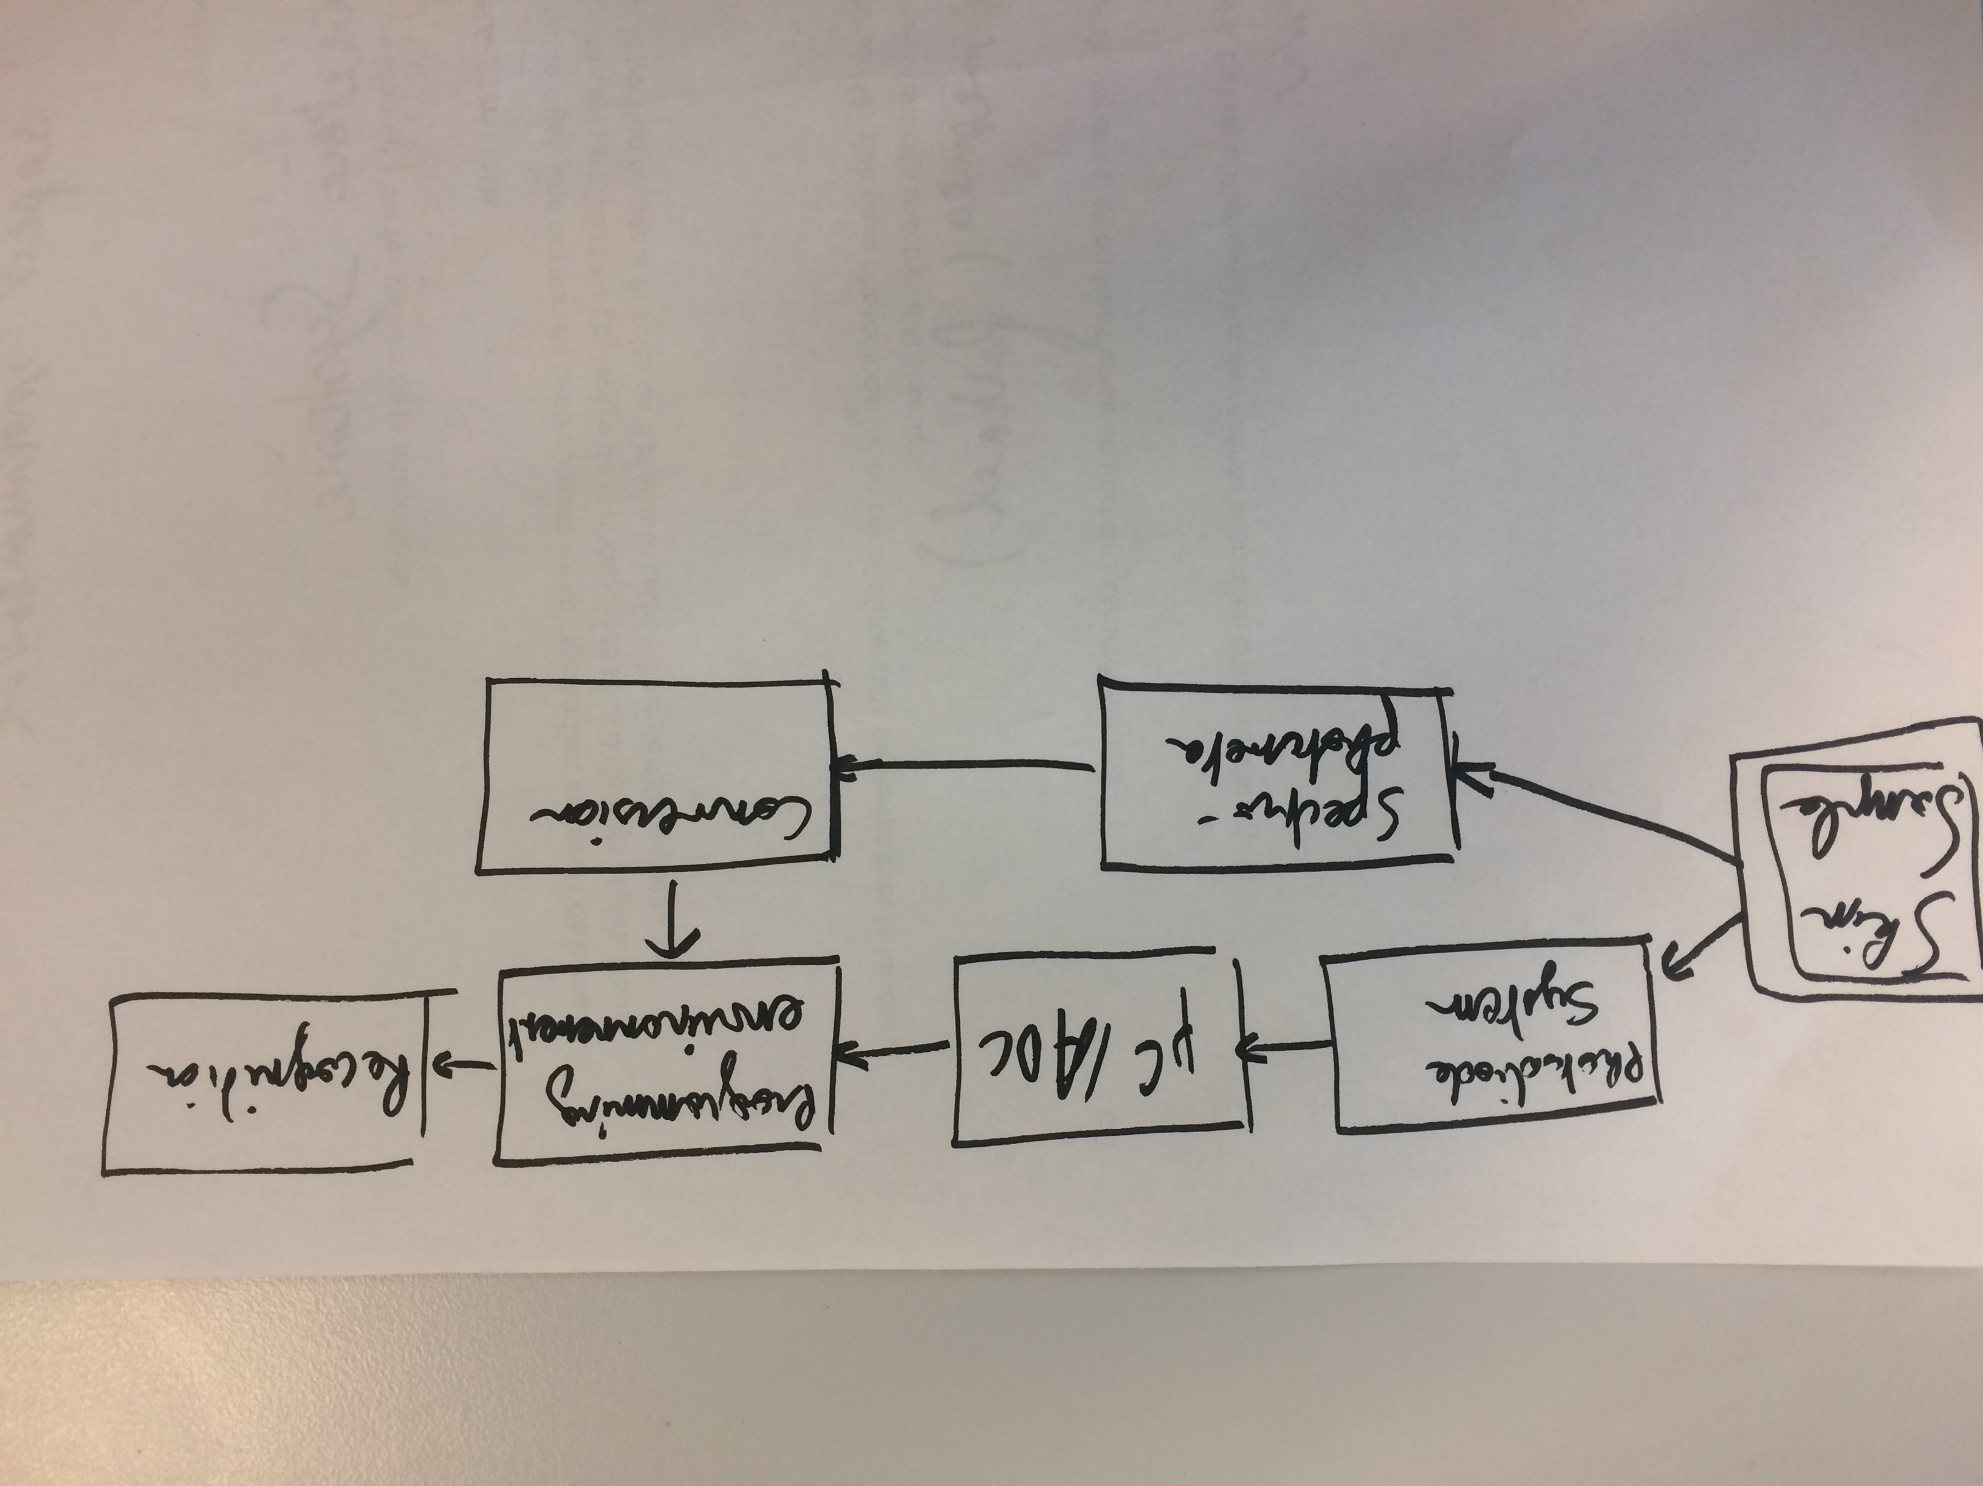

Fig. ?, Block-diagram of the recognition system. The skin sample is scanned at different time intervals in the system, and in the spectrophotometer.

When the dataset entry is created, we have done several acquisitions for the same angle in the system (depending of the step motor position, calibrated with an offset, calculated when the emitter wasn’t turned on), and multiple entries for each spectrum wavelength with the spectrophotometer. This permits to measure the mean and standard deviation for the different acquisitions, which models the multiple presentations of the subject, through statistical machine learning. Thus, we differentiate two process, the learning phase, consisting of the acquisition and storage of the data, a vector including the polar diffusion diagram and the light diffusion spectrum, and the recognition phase, consisting of acquiring a new data entry, and find the k nearest neighbors of this data entry, determining the class of this vector, in a supervised way. In order to validate this biometric methodology, we performed a cross-validated recognition task, and the results will be discussed in the part 4.

3. Experimentation

The device is tested on seven different subjects with different skin color, with apparent melanin concentration discrimination, as they are Caucasian to African, for the validation of the scattering spectrums. Via this protocol, the spectrums are obtained in Fig. ?, each point (lines) on these spectrum corresponds to the characteristic vectors which will be our training examples as the input of pattern recognition tool containing k-nearest neighbors (k-NN) statistical approach for classification and regression in learning algorithm. This learning algorithm contributes to the individual identification, namely recognition, by using data acquired by scattering spectrum.

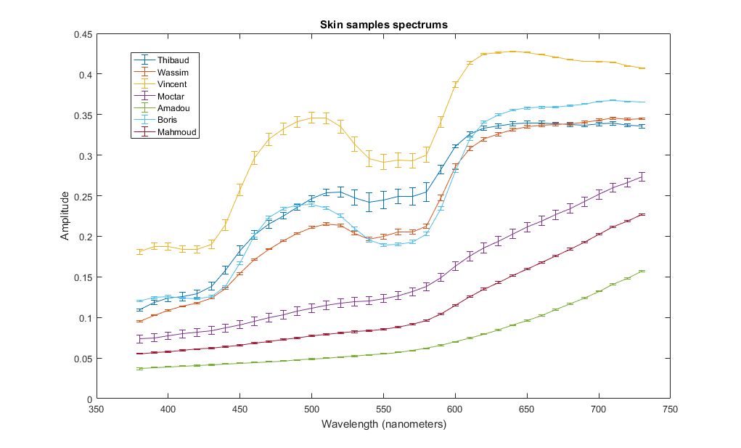

Fig. ?. Skin samples spectrum, for each of the seven subjects, who scanned the back of their right hand with the spectrophotometer.

Besides, in order to observe variation of the spectrum due to the tissues humidity, measurement of dry and humidified skin for each 4 subjects is effectuated, using our system, as we can see in Fig. ?.

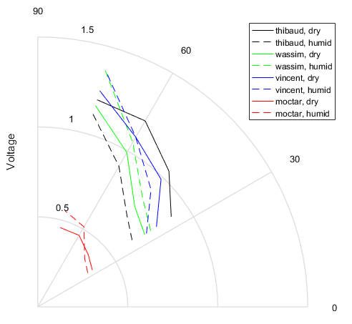

Fig. ? Polar scattering diagram of subjects, full line representing dry measures, dashed line for humid measures. Humidification was applied by applying water on the back of hand, resulting of a fine water pellicle.

Finally, we feed the data in the recognition system, computing a cross-validated task, achieving up to 100% accuracy as we can see in the Fig. ?, and illustrating the performance of the classifier with a receiver operating characteristic curve, Fig. ?.

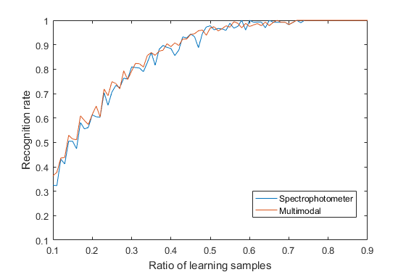

Fig. ? Recognition rate for the two modalities of the recognition task. In blue, the recognition task was done with the spectrophotometer data, in red, all the data (with our system) was used. We fed only the potential at one angle with the photodiode.

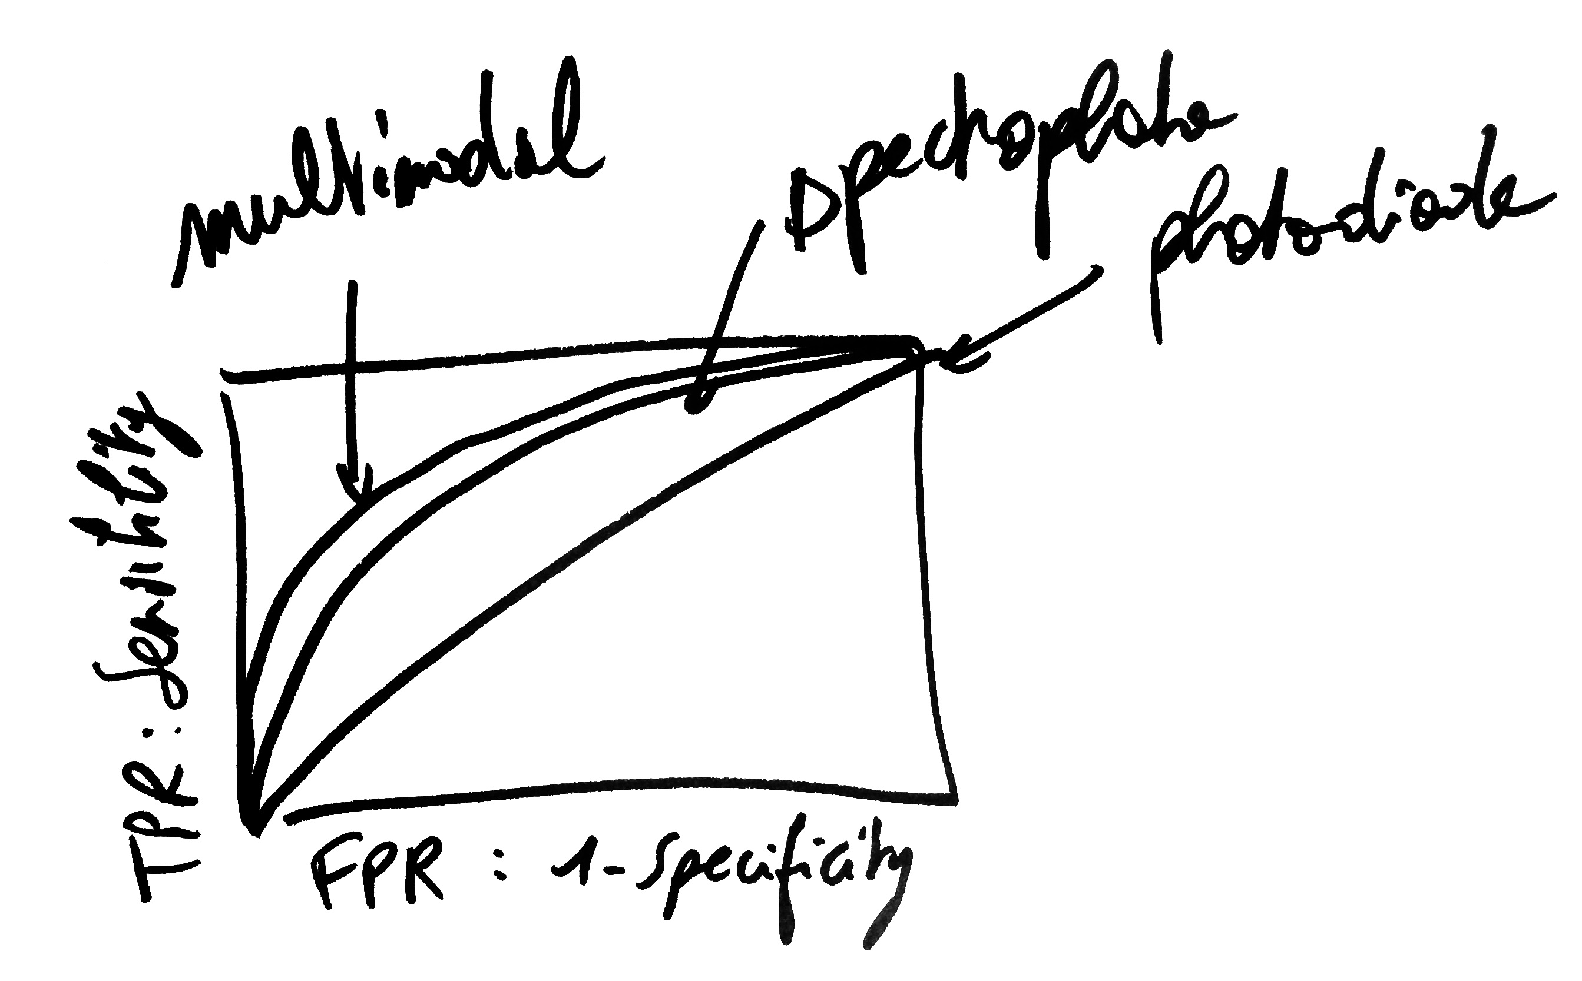

Fig. ?. Receiver operating characteristic curve of the predictor, the point at (0,1) is representing perfect classification.

4. Discussion

Les données